Geometry: Unit 5, Lesson 5
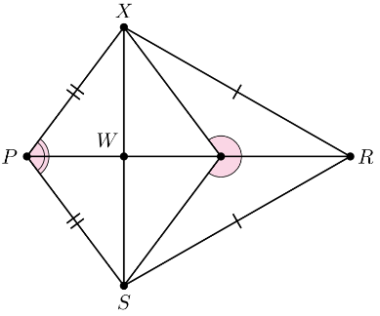
- Quadrilateral $PXRS$ is shown where $∠XYR≅∠SYR$, $∠XPR≅∠SPR$, and $\overline{PX}≅\overline{PS}$. Does the quadrilateral described match the given image?

No

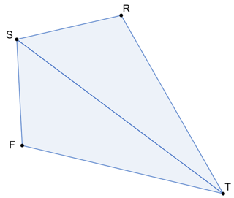
- Polygon $SFTR$, where $\overline{SF}≅\overline{SR}$ and $∠RST≅∠FST$, is shown. With the given information, it can be concluded that $∆TRS≅∆TFS$ because both triangles share what?

The side, $\overline{ST}$
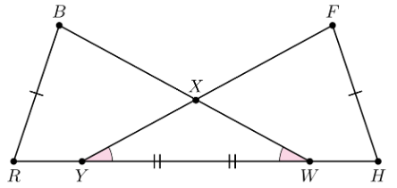
- Claire marked the diagram based on the given information, as shown. Given: $∠BWR≅∠FYH$, $\overline{BW}≅ \overline{FY}$, $\overline{RW}≅ \overline{HY}$, what did Claire incorrectly mark?

$$\overline{BW}≅\overline{FY}$$

